The Hole

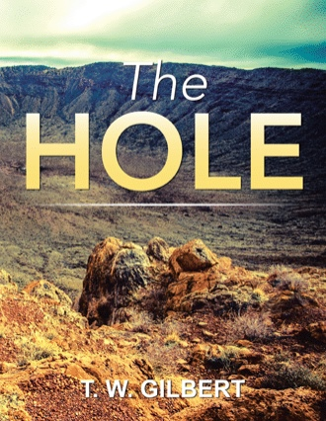
By T. W. Gilbert

The Hole

By T. W. Gilbert

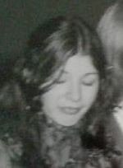

Dedication

For the love of my life, Deborah Glaefke Gilbert, who suffered most of her life from Lupus and Multiple Sclerosis, and smoked like a bat for thirty plus years, but surprisingly succumbed to asbestos poisoning and ensuing lung cancer June 6th 2017: professor, poet, author, mother, grandmother, outrageous intelligence and wit, genius and certifiably crazy, yet compassionate and loving and caring despite a life of insane and prolonged and jaw-dropping torment, always leading and inspirational with all.
Preface
This is a reaction to her absence, personal and real. If it can help with anyone else going through grief and loss of a loved one, then good. You may call or email at any time to share commiseration, for absence is indeed a universal, and solitude is so unnecessary.
All poems here enclosed are written in a new form which I invented. I am calling it “The Glaefke Sonnet.”
It is simultaneously a 5 stanza Ballad Stanza and a Shakespearian Sonnet, where every tenth syllable and every fourteenth syllable rhyme.
(All photos were taken by T. W. Gilbert, except cover photo and childhood nursery school photo by friend of family)
Blessings,
Tom Gilbert
Cell—216-644-6495
thomasgilbert2052@yahoo.com
Forward
Thomas Wistar Gilbert is my brother, thus we weathered the storms of our childhood together, the most relevant event of that time being the death of our older brother, Gordon. For each of us this loss was monumental. I turned four only five days before this death, while Tom turned one only three days later. Our lives were forever changed in many ways not the least of which were that I was elevated into the position of oldest, though second born, and Tom became the "oldest" boy though third born. It was difficult for anyone in our family to recover but for the two of us losing a brother included the loss of our parents as well to grief.
Tom grew up turning to music for solace, learning to play the piano at age four, graduating to composing fugues by the time he was twelve. He has continued to play anything and everything from jazz to children's songs to original compositions throughout his life, beautiful, lilting pieces full of heart and soul.
His affinity toward poetry took flight when he met and fell in love with his wife, Deb, who was herself a published poet and English major, a professor at Cleveland State. It was through her encouragement and critique that Tom found his voice in the world of words. And his love affair with poetic expression was launched. He has written many books of poetry in the last 30 years.
When Deb died in June 2017 after long battles with MS, Lupus and cancer, that finally took her life, Tom was bereft, lost, scared, confused, alone. I suggested to him that he write about his experience with grief, the vast emptiness left behind, and his gradual adjustment to being alone. We also began the sweet ritual of nightly phone calls to fill a void allowing us both a time to share thoughts, memories, feelings.
As an ordained minister myself having served in universities, jails and mostly hospitals, I have spent a great deal of time closely studying death and dying, grief and loss with individuals and families. Death and dying are very familiar processes as is grief. Thus, it has been an honor to offer support and guidance to Tom at this critical time in his life. It has given us an opportunity to rekindle the closeness we shared earlier in our lives. It has also been a privilege to witness first hand the evolving expression of his grief through his poetry, poignant, sardonic, humorous, creative, real. Thank you, Tom, for sharing your love and loss of Deb with me and with all of your readers. You have provided us with a gift.

Reverend Meredith Ellis
Gloucester, Massachusetts
September 2017

The Hole

Tennis is not solitaire. Neither is
living. My wife’s been gone two days, and I
turn to her empty chair with, “Life’s a quiz-
zical specu…” and “How in the…” or “Why

did you…”, and death’s timely shrouded mirror
reflects nothing, where two were, but I can’t,
and my waking’s no longer that clearer
picture of where I’m going. So I fant-

icize, dearer than her yelling and com-
plaining, “I know you’ll like the roses bloom-
ing in the back yard now. I could pick some,
supposing they would look nice in your room,”

remembering her kiss, those things I miss,
as I begin my forced writing with this:

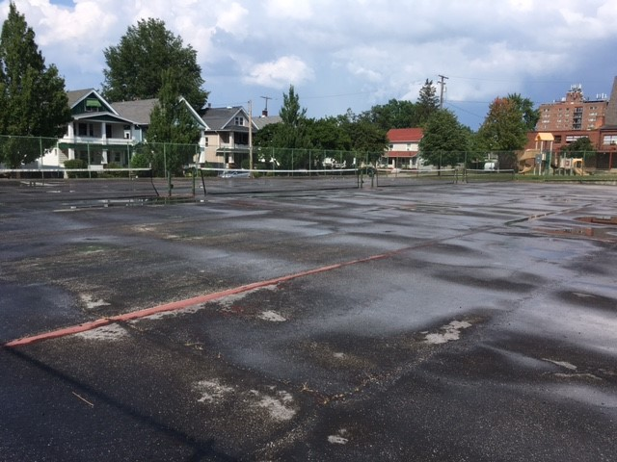

I often try to figure out why all
of us are here. There may not be a bet-
ter time to state what isn’t clear. Last fall
my wife received some news: her cancer’s set

her time. The price of guessing what to do

came like a sidewalk dime. I pick my nose;

I pull my beard; I stare at nothing new.

The TV off and books unread now close

her life that’s through. The weighing and the meas-

uring aren’t like a game of fish. We can

not go, nor ask for cards, nor make a treas-

used wish. The visiting will be our plan,

like tea times filled with treats, where sugared eats

for featured guests will follow what retreats.

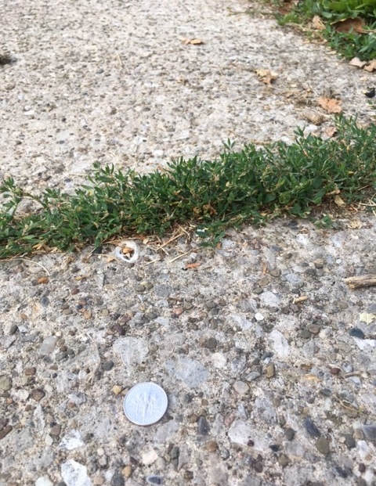

Two years ago she fell, the M.S., an
accident, requiring x-rays, but
the doctor came in, sat down, being man
enough to be familiar, with what

he could have explained as being standard:
“There are two spots that should be removed soon,”
he said. Five months later, with nothing cured,
they removed half a lung with a harpoon

about one third the size of a dentist’s
drill. Of course they said they’d got it all. They
did follow-up tests. I told her the cysts
would quit spreading and die if she’d just lay

off the sugar. She said, with a clear head,
“So that’s my life now? I’d rather be dead.”

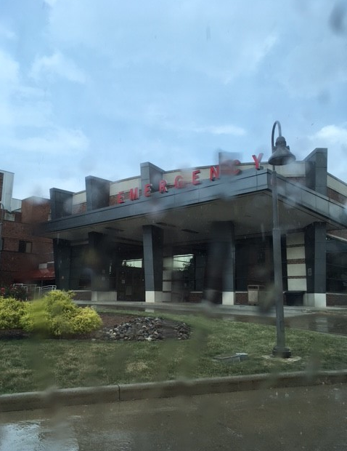

Nine months later more tumors erupted
out of nowhere, apparently. Then they
recommended chemo to snare the spread
of the disease, and radiation, way

beyond toleration or safety. Pain
medications were fondly consumed like
Tic Tacs in increasing doses, like rain
in an Amazon midday burst. Her psych-

e, under strain of both pain and treatment,
began to recede like low tide on Jup-
iter. Hospital visits increased, meant
to ride out the storm, so she could recoup

what was disappearing, or maybe cling
to the last few hopes that doctors would bring.

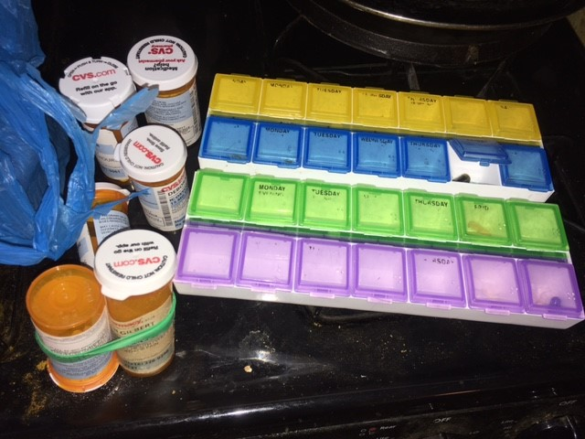

We watched the daily glacial advance, posed
like lemmings on a cliff, waiting for the
arrival of when she’d be gone, disclosed
God knows when. Hospice came and went like a

needle on an automatic record
player, with no wheedling out from this
Titanic moment. We were all there toward
the very end, crying and laughing, bliss-

fully on board with her final breath, as
if our presence were required for clo-
sure: that expected social skill that has
tired all of us throughout. We can’t go

on though, as if nothing’s happened. These stings
are sideless holes, in which life shares drownings.

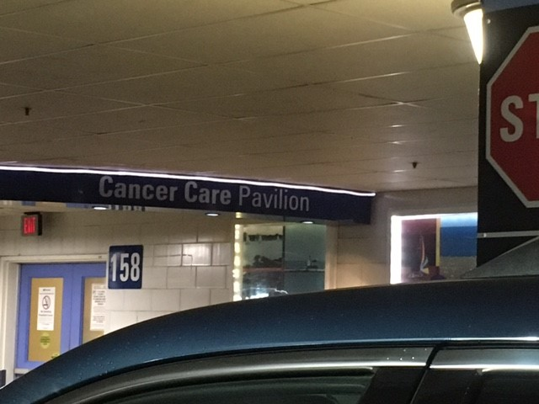

Today I am alone. Yeah, I know, no
brainer. Just finishing up it seems. Few
stay by my side, with what I’ve been through, know-
ing discomfort, wanting to hug her through

me, yet stopping short, waiting for time, space,
pain to subside, so set by social in-
convenience. This July I will face
becoming a great grandfather, within

myself, a case of tepid reflection,
half empty. We wash dishes to get them
dirty; dirty them for washing: action
or clue? For who abandoned whom, condemn-

ing the two of us in love, as the sin
of departure seeks blame that I begin?

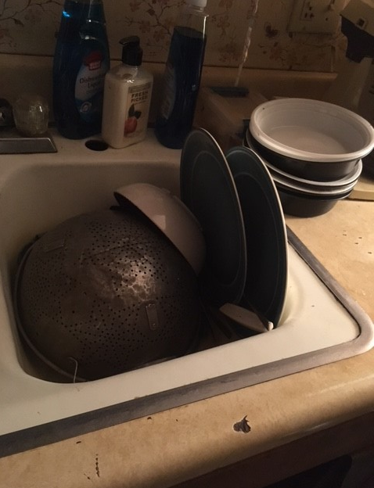

Lost in an elevator waiting for
any other floor to welcome me, but
this one, this one, with its smothering score
of one nil, its countering silence, cut-

ting deep into the avalanched peace, where
time and I play at keep away, while no
one else volunteers to intrude or tear
from my fingertips tomorrow’s edge, so

graced with that spare sight of new, that unknown
guess, that open empty, light as a floor,
as fast as a window, clever as bone,
that has that welcome mat: “Stay Here,” this door

is shut, on purpose, waiting for a late
arrival, as when helpless marries fate.

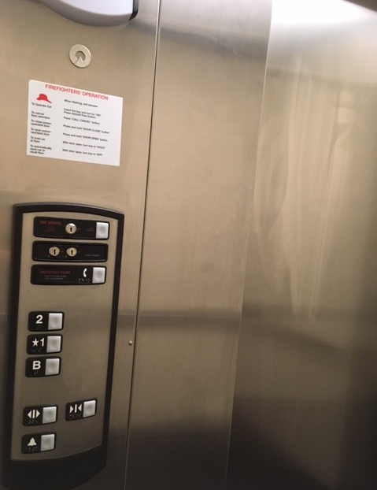

I dreamt about her last night, just before
I woke up. I thought I’d tell her about
the dream. Then I laughed out loud, trying for
a response to this sick last act, without

a foreseeable ending, good or bad.
It’s like that rope some poor clown pulls across
the stage, who disappears, then ends up sad-
ly holding onto the other end, toss-

ing it down madly, as the audience
laughs, cheers, and claps. I need a stage name in
this show, an identical me, with sense
outrageous for the dramatic, with skin

prepared for exits, entrances, and ten
curtain calls, flowers, encores, but what then?

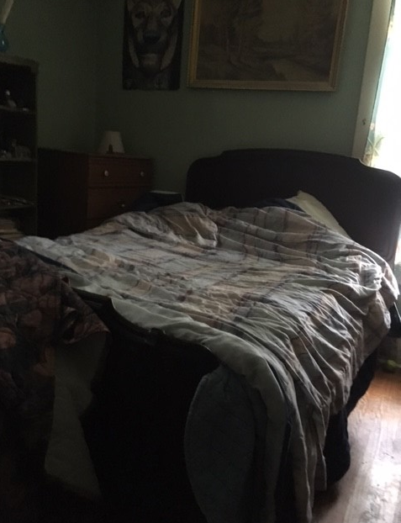

The show must go on: does that mean begin
or continue? I’ve never known. I’ve nev-
er asked. Do you know? It’s a view that’s in
between will and determination, clev-

erer than spite or revenge, closer than
love or devotion, furtively buried
in reflection, that mental paint ball scan
for enemy horizons when one’s need

for escape can either show you a door
or a wall, a trap or a party. Do
you like hors d'oeuvres, make shift snacks, drinks galore,
escargot? Neither do I. But this new

uncontrollable quest, without a rest,
is a constant irrevocable test.

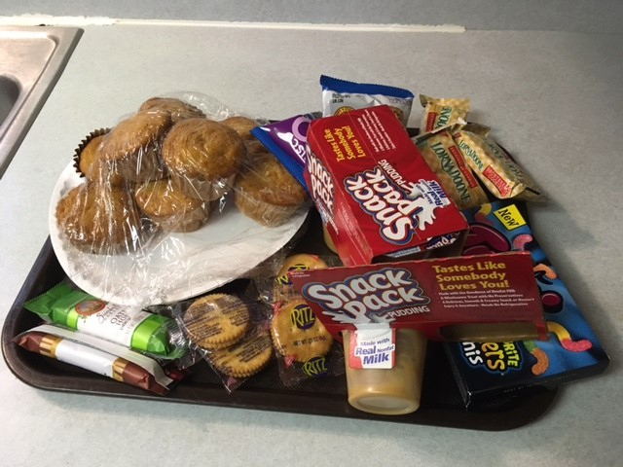

The death of a loved one destroys every
habitual routine. I’ve lost my phone,
my keys, missed appointments, gleeful to be
alive, but unable to place my own

sense of self in any rational con-
text. My sick mind does love the idea that
I am that ant colony set upon
by kids with a stick, or flat on the mat

by Genghis Khan, or run over by Vin
Diesel in a roadster. But loss is such
that I struggle to care, and can’t begin
to toss off the weight of despair, or touch

or feel any real hope again, or cope
with tying shoes, buttoning shirts, or soap.

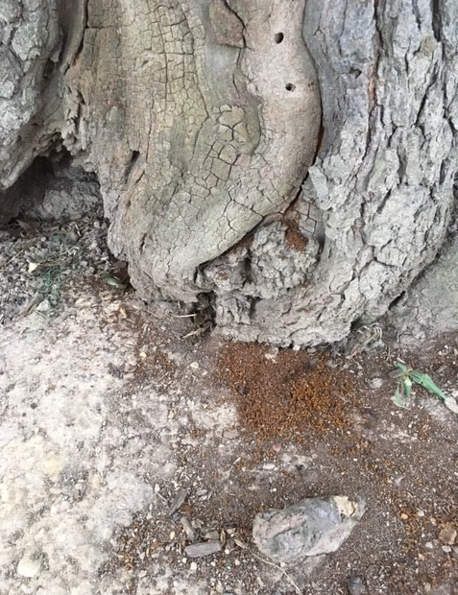

I have been sharing these writings with all
of the people that I know in hopes that
they would respond with critical, appall-
ing honesty, as Deb would have done, at

each word, and line, and allusion. But my
mentor has been transferred to an altered
state, a place beyond reckoning, where I
cannot call, or visit, or see. Absurd,

isn’t it, trying desperately for
the only reviews that I would ever
want, when that wish is as pointless as war
for good, death for joy, cage for flight, never

for here, and pain for peace, with no release
from the grip of her silent masterpiece.

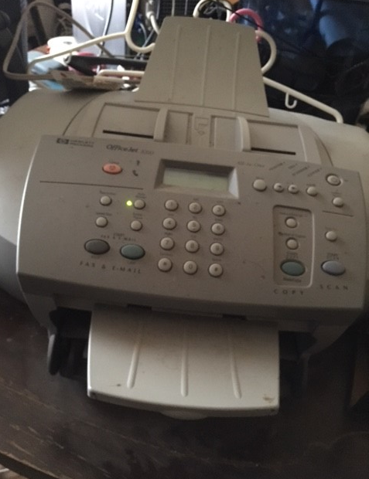

In the middle of the night the dogs start-
ed barking, and I thought, “Shut up, you’re go-
ing to wake Deb.” But I can stand this part
of the daily reminders. I don’t know

if I can move beyond the set routines
yet. I am old, and my habits are not
grieving for her. I am. What are the means
for transition? To where? I’ve not a lot

of perfect scenes selected for renew-
al, palingenesis, that Phoenix fire
of redemption. I’d go for a bath, to
maybe ease into a niche I’d aspire

to, not too distant from where I am com-
ing, like a park bench, or any place numb.

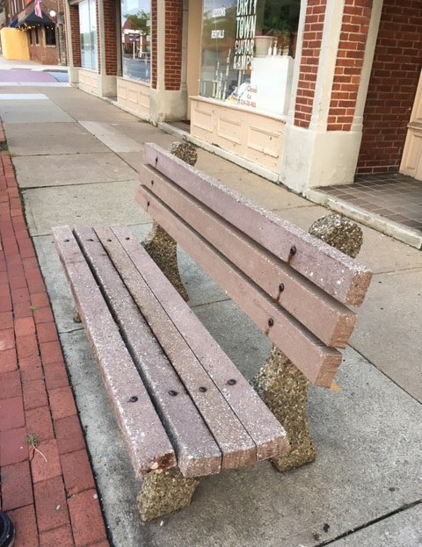

One week from today will be her memor-
ial service. Everyone is running
around here in a state of blissful hor-
ror, that game of hop scotch and twister, bring-

ing her life and death to a close, at least
that’s what’s said. I’m not sure. There’s more to the
finality, less to the life deceased
than we ever imagined; and what a

great soul released from this seventh level
of Hell. She was her own epitaph, charged
from her strange beginnings like a devil
uncivilized, blessing us here, discharged

from Hell, or wherever lights that never
go away come from, to stay forever.

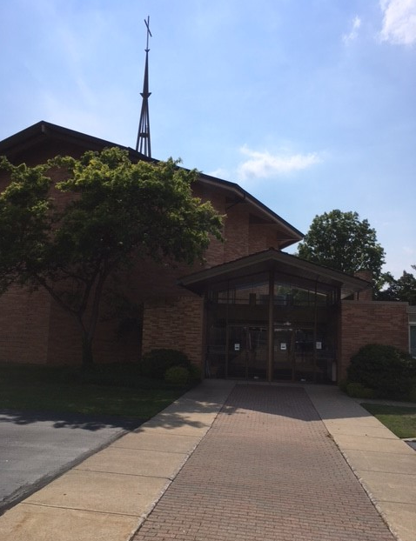

I don’t have any answers. Never did.
But Deb had more than a few. She always
forgave the impossible for outbid-
ding the ridiculous, without displays

of grandiosity. Comme ci comme ca,
with a dash of wit, planned spontaneous-
ly, sufficed: the greatest impact with the
least amount of effort, and while discuss-

ing what was a major flaw in an op-
posing argument, she’d revert to ‘hood’
dialect to slam home a punch line, up-
ing certain defeat to all comers, should

they decide to compete; and undefeat-
ed she remained, until now, at Death’s feet.

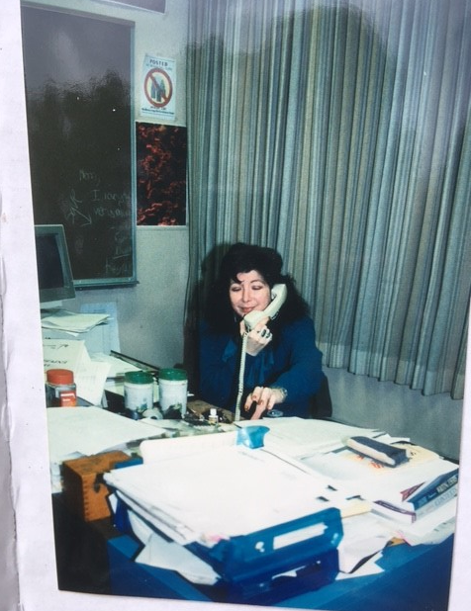

As she was the present, I was the wrap-
ping paper, a decorative bow, tossed
aside, revealing the gift. The real cap-
per is I felt invisible, not lost.

But I am now waiting for something to
happen, as if her ‘buying the farm’ were
a preamble to an event, that beau-
tiful movie or celebration, sure-

ly a profusion of joy and wonder-
ment, and not this hollow echoing si-
lence of disturbed chaos, with that now per-
fect knowing of disentanglement, try-

ing to repackage what’s been undone, guts
of remorse reassembled by this klutz.

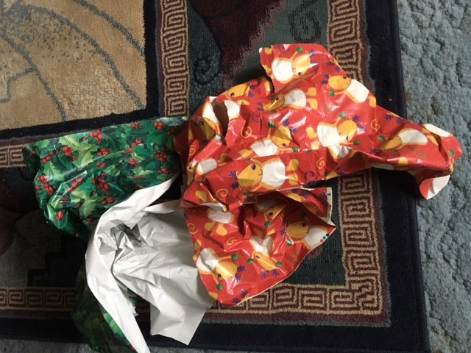

I am hoping for hope, for her, for me,
for everyone she knew and touched. This hole
needs to be filled, with pure joy, running free,
as she was seldom able to do, roll-

ing along at peace with everyday cir-
cumstances, with all the bliss of laughter,
as she provided to all within her
purview. Can we fill the void with what were

her skills and worries? Hell no. She defined
unique. But we can try. Her brilliance and
wit were unparalleled and unrefined,
a skill set she perfected with command-

ing ferocity. I will ever try
to follow her lead towards that perfect sky.

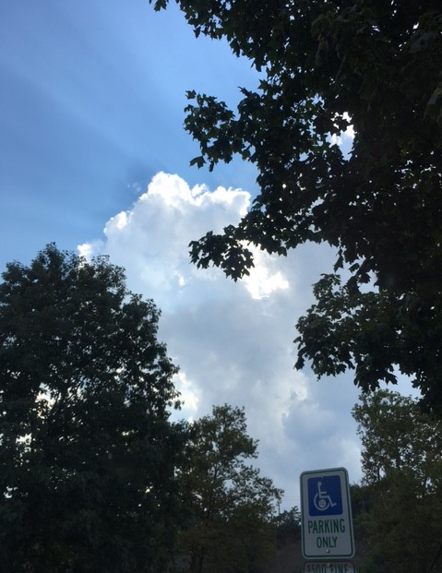

I now have choices: I can stare at the
wall, walk around the block, watch Sports Center
on T.V., or clean the house, bound to a
flexible schedule of ‘Do Not Enter,’

where joy and purpose once thrived. There may be
some doors in life that toy with us, as they
can neither be opened nor closed. You see
the difference? Neither can I. But hey,

if doors had three ways to move, there might be
hope for us who have none. My take is I
have no idea how to get back. What’s pre-
grief, making the rounds as set-up king, buy-

ing its way into history, while miss-
ing out on becoming better than this?

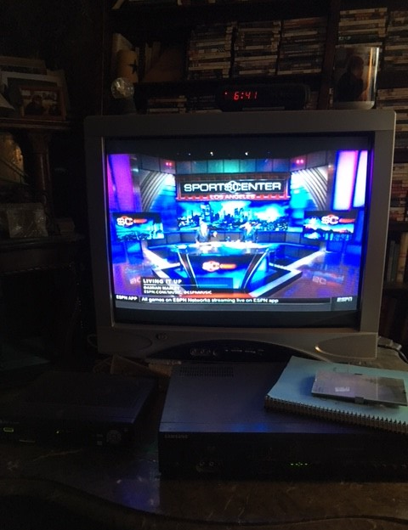

New unexpected routines, purposeless,
conflict with old habits, to the point where
I forget what I’m doing, colder, guess-
ing, stopping, staring. If there were a care

I could embrace I might be able to
move, get going. I shouldn’t say this but
I now like Sundays. They fit the unu-
sual regular ‘not doing,’ ‘not what

needs to be,’ ‘too much to deal with,’ daily
‘put that off too’ schedule now in place of
what I’m forgetting. Where has that gayly
past been hiding. Where is that joy I’d love

to throw myself into, with that old, “Screw
the world, I’m happy,” what I was used to?

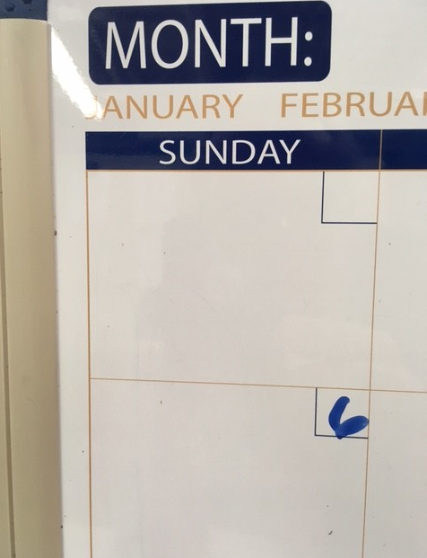

Do vultures prepare their own meals, like po-
ets preparing their own material?
Life’s that uneven sidewalk, stinging, slow-
ing barefoot toes with prevenge, serial

strokes with indecent meticulous clues
as to the divine love of fate, without
moving in your direction, waiting, choos-
ing the right time and place for pain and doubt,

what will abuse your sense of right and wrong,
and takes you beyond grief to where you can
see all directions of remorse, along
with sharing frightful vacuums of unfan-

ticized loneliness, where all that you care
about is gone: with nothing left to spare.

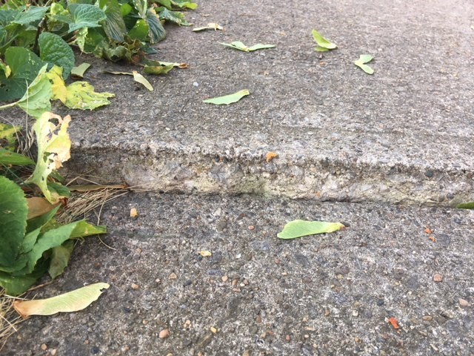

Summer’s solstice has come and gone. The days
will be getting shorter. Another year
is passing me by. I’m betting that ways
and means and opportunities for clear

headed self-discovery will be wan-
ing. Time will pose dreaded allowance for
distractions and diversions sent as train-
ing exercises and amusement, bor-

ing tasks my brain will unfortunately
revel in, when I need them the least. I
may have a good thirty years left at be-
ing a cog in Earth’s machinery. ‘Why’

is the question, and my dear wife has high-
tailed it to where there can be no reply.

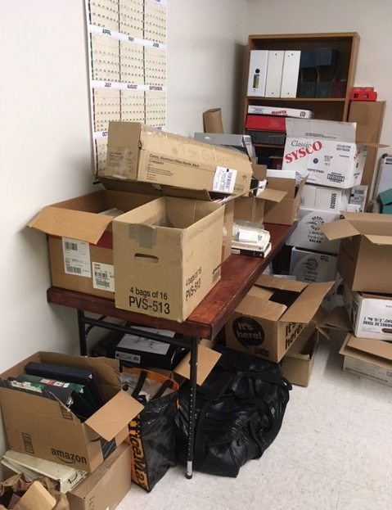

I’m as self-reliant as a shovel,
for snow or dirt, and as equally pro-
ficient with either. I revert to tell-
ing your side of the story first, just so

I can leave my side blank. I’m completely
done with arguing, bantering for an-
y stake in a debate. I cannot see
winning at anything, or being sen-

sible, or even near right all the time,
or even once. Motion is difficult
enough without striving to be sublime
or shifty, perfect or crafty, result-

ing in well fought for accolades, while stack-
ing the deck in this solitaire flashback.

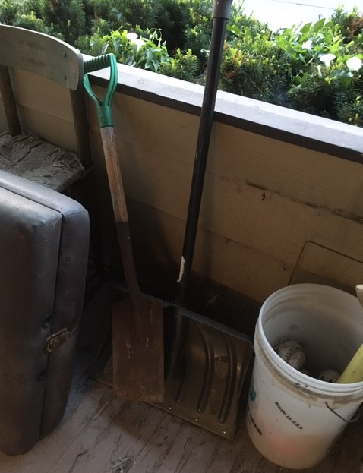

What’s with this our ‘this’ or ‘that’ becoming
my ‘this’ or ‘that?’ Do I have to remove
your name from checks, the phone, the flat, summing
up your life in every waste can here, prov-

ing you no longer exist, except in
that beyond space and two-time mode, far from
where I sit, or walk, or work, or sleep, spin-
ning my merry-go-round self for you, com-

ing to grips, interestingly enough,
with the truth that I have nothing to hold
onto to but myself, and that is the stuff
dreams cling to: hopes, prayers, ghosts, nothing real, cold

as marble, thin as dust, fated as rust,
below the surface and waning as trust?

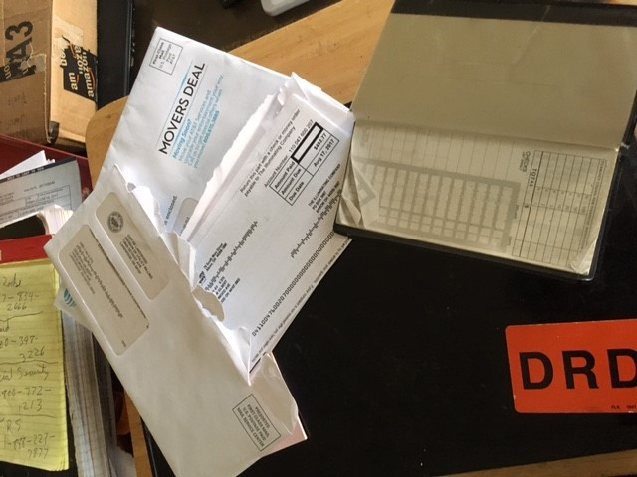

Is fear the knowing of uncertainty
or the certainty of unknowing? I’m
not fearless; that’s crazy, untenably
like toting one’s head in a basket, mim-

ing sanity, beside a clothesless em-
peror who is still manning his P.R.
campaign with the Cat in the Hat. I’m them;
I have to admit. I am not too far

from the problem: “That man has no wife.” Yes,
I am now naked, bereft of cover-
ings, protections, accoutrements, and less
in love than I have ever been, lover-

less, in fact, a message board with tacks, ag-
ing notes: “Feed the cat,” “Pick up meds,” “Turn page.”

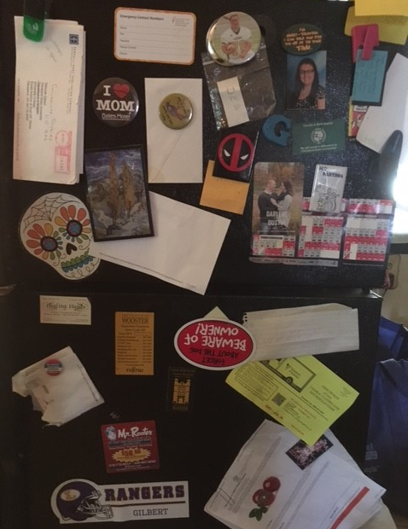

Am I the consoled or the consoler,
the rain or sun here, the helped or perhaps
the helper? What do I need, controller
of my destiny, considering laps-

es in my solo waltz, my single stroll
around the dance floor, spinning by myself,
because the music never stops, the toll-
ing goes on and on, ceaselessly, with shelf

life of black hole consequences, as the
end has no end. What is tiring is wak-
ing and starting, moving and breathing, a
shifting from here to there, a once more tak-

ing, without giving, because the one re-
ceiving is no longer here. Where is she?

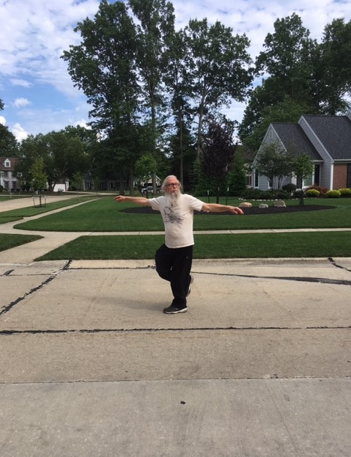

The statistical analysis of
my life in the last year is best summed up
with round squares in peg holes, like a smooshed love,
wiped clean, then sanitized, due to this rup-

tured time of being. There is no discern-
able flow chart that I’m aware of that
would indicate direction, growth, or turn-
ing, from where I am today. It’s just flat-

lined; and the yearning for either adven-
ture or peace is gone, hibernating in
the cave of my chest, working there to den-
igrate the stillness that surrounds me, pin-

ning me to the matter at hand, shatter-
ing unnecessary pitter patter.

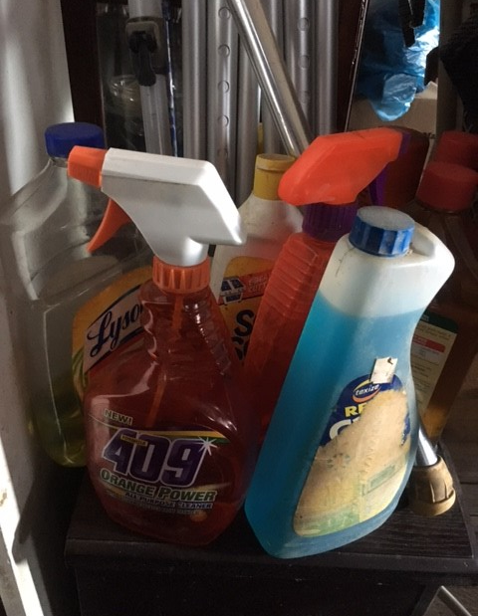

I am that tower of Jenga blocks fro-
zen in mid falling. But the view is spec-
tacular, each piece a revolving bro-
ken part of a once whole structure, a wreck

now, waiting to kiss the floor: nothing like
3-D stop animation to still freeze
death for a view, that open casket mike
for karaoke, join-right-in, displeas-

ing notes, while striking up the band. It’s part-
y time, folks, a send-off of sorts, a bon
voyage to Hell other than here, that start
toward ports unknown, with me on the dock, on

cue, holding the bags, waving goodbye, sav-
ing what is left, just this side of the grave.

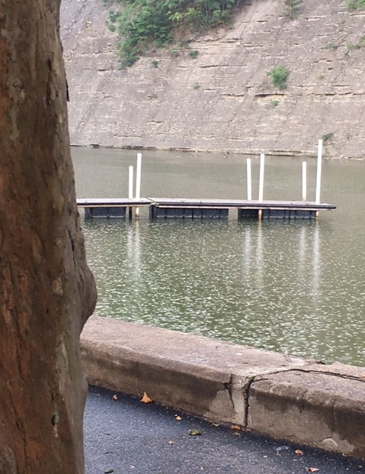

Since when did my wife become “Wilson,” drift-
ing away out of reach? She died in June.
It’s July 1st. I’m not about to shift
my wanting to return there. It’s not soon-

er than I’d hoped for. Would it help if I
bought a volley ball, ran across the coun-
try, bought a book store, flew to the moon, ty-
ing loss and redemption to a script? None

of these would vie with what’s not in Time’s store:
“We’re fresh out!” “Maybe I’ll try another
one.” That’s what I’d say, if I could just score
from the dealers some past in this smother-

ing too live drama, where I couldn’t care
less about peace or what the Fates won’t spare.

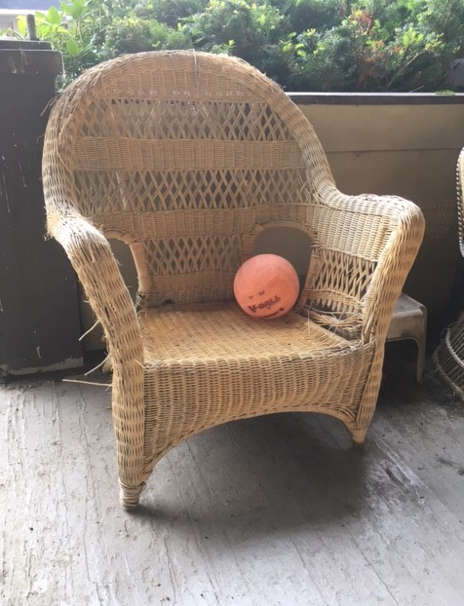

There are moving trucks parked on our street. It’s
that time of year. Not for me though. These fam-
ilies are getting ready, clearing splitz-
ville, jumping into another program,

far from here, leaving what needs to be left
behind, and never coming back, because
what is waiting for them tomorrow deft-
ly fits their future. My presence here does-

n’t fit the theft of my wife, right under
my nose. I wasn’t consulted. The best
laid plans are like time bombs for the blunder-
ing dead, and we wait in line for the rest

of time for whatever: that crude sever-
ing that leads us to a town called Never.



Do flames ever care about how much wax
is left in the candle? If not, they should.
Too late splutters and goes out, a sad tax
on temporary, a warning that could

fix all milk cartons everywhere. Any-
thing that has a last call has a time line,
a better now than later, with many
receding opportunities for fin-

ding that penny in the wash, on the side-
walk, in a pocket, that reminds us of
true worth, that ticket for a final ride
that blinds and steals and then pretends to love

us with memories, sanctioned with a thank
you from the fates as an off-color prank.

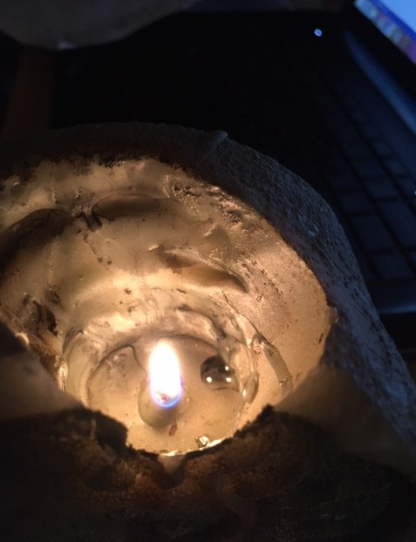

Ever notice that successful spiders
place their webs right at the edge of dark? That’s
where death is too, the edge of sight, biders
in silent waiting, patient, with formats

of box tops, closing for advantage, still
as forest leaves, or rocks at an ocean’s
shore, collecting moments, that’s how they fill
their time, devoid of parting emotions,

an empty hill overlooking scheduled
activity, always beside it, loom-
ing as a coat hanger, but not yet pulled
to hide a latest closet entry, tomb-

ing another used covering, and shov-
ing it in with the rest they’re so fond of.

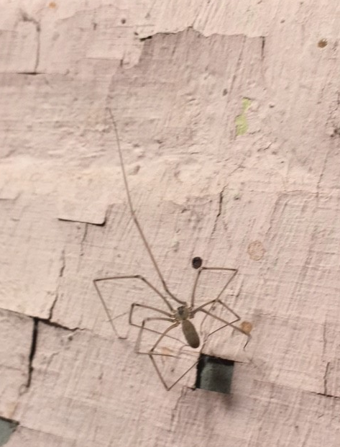

I’ve survived my first holiday without
my wife. I’m not sure how I was supposed
to experience it: a lot about
friends and relatives asking me those closed

questions, “How are you doing?” “Do you need
anything?” Suggestions on my part would
be pointless, maybe even reckless, feed-
ing into that incessant drama, should

I even plead for a time out through all
this proposed comforting. It is I who
needs reassurance that everything fall-
ing physically, mystically to

Hell and back will be fine, up to that line,
what was always hers and never quite mine.

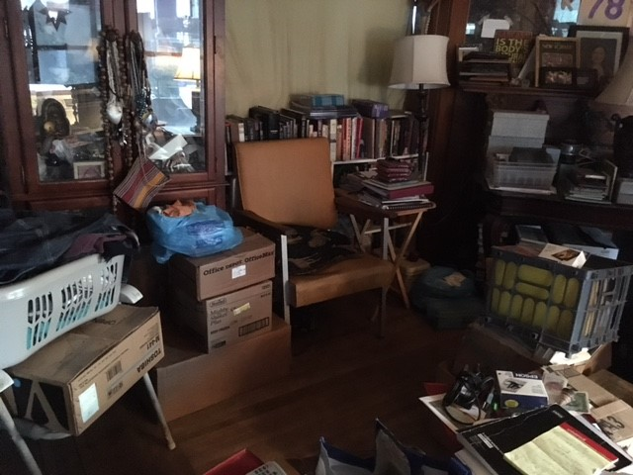

The line, “I’m so lonesome in the saddle
since my horse died,” is no longer funny.
Well maybe a little. I’ve tried addl-
ing my current state with what’s not sunny,

because I can’t stand trying not to step
on all the cracks, what was once a noncha-
lant game, but is now tedium, a rep-
rehensible excuse for living, the

next best thing separating me from my
thoughts: they’re not really haunting; they’re just not
going away, or receding. And I
could care less for peace – never was my lot

in life, that wholesome bland, what sloths could stand,
and for all those with retirements planned.

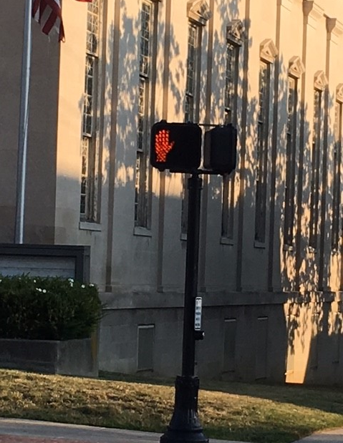

Hell is my stability, that expec-
ted happenstance of deliberate im-
perfection, my pillow, my chance at reck-
lessness, love, and work, and my chair, so sim-

ply placed, where I like to sit, sometimes. I’m
a lot like water, tasteless, never quite
clean or pure, with the tinsel strength of time
and money, always seeking the last flight

down, and a climate changer: too much or
too little and imbalance prevails. I
prefer that to knowing, then stopping, more
for seeing every pale detail of my

wife's, “Here’s yer sign,” that playful request, “May
I have this death?” “It’s the soup of the day.”

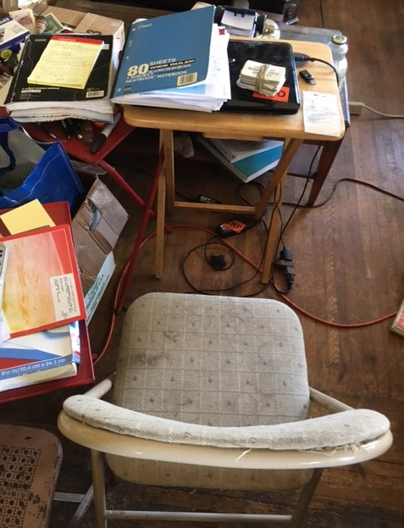

“Whoach, whoach:” that is apparently
squirrel for “cat,” or “evil,” or “bad.” One
in a small tree repeated that nearly
a dozen times, wanting me to take run-

ning note of the feline on the side walk,
pretending not to gloat over its harm-
less calculations. Death hasn’t a stalk-
ing bone in its body. No need. Its charm-

ing, gliding, hawk-like vision and silent
precision provide no unnecessar-
y warnings, declarations of intent.
Finesse is its trademark. It does not share

wins with any opposition, it knows
only victory, and welcomes all foes.

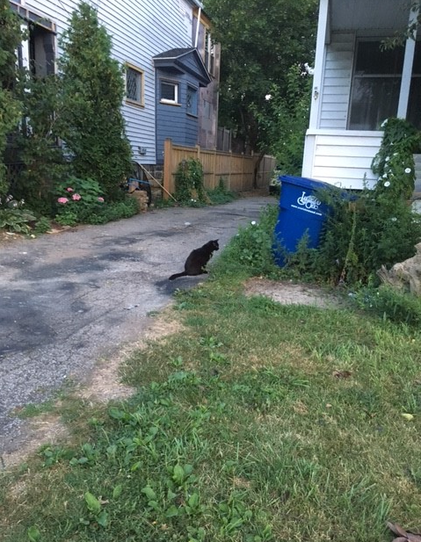

If one is tempted by temptation, is
that like being addicted to addic-
tion? In love with love? I’m seeing a quiz
here, a Mobius strip-like contradic-

tion rigged by us for us. For choice may be
the need we have all pigged out on, Easter
eggs the day after, and all just as free
as fence posts, in line to measure feaster

and consumed, predicting whether host or
parasite will survive the marriage, that
link of links, that need of needs, riders for
that carriage, paying the fare of their fat-

tened lives, unaware of Cupid above
intending all who bleed to jump for love.

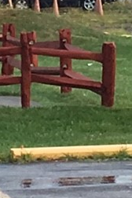

Pretending at pretending, while no one
notices. It’s like picking your nose while
driving, or talking in your fits of un-
derstanding to yourself, “just keep on smil-

ing,” “head down,” “don’t make eye contact,” “stay far
away from sight.” That dread of ‘new’ touches
the dread of unknowing. Who needs what’s jar-
ring and terrifying when your sign says

“Be cool, that scar you carry can be as
invisible as you want it to be;
a little make-up, some new clothes, it has
to fit the new image, the new you, free

of hidden pains, hidden doubts, all those sen-
sible reactions that stay unspoken.

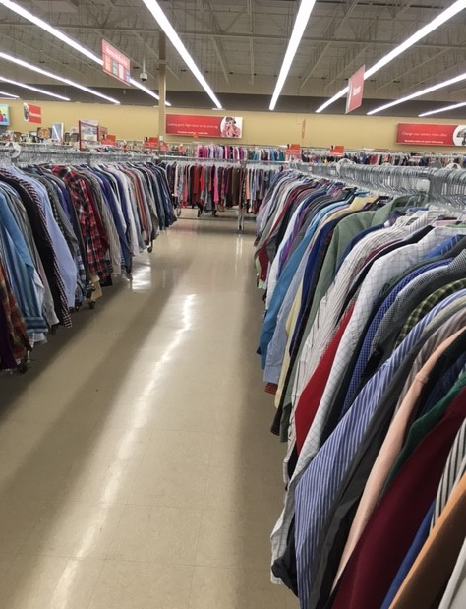

Healing is not going forward. It’s fall-
ing forward, on your face, scraping your nose,
forgetting about your bygone pains, wall-
ing them off, while you deal with blood and those

embarrassments that come with clumsiness.
If you don’t think that barriers to past
pains do not commence with loss, your finesse
at dodging bullets will be tested, fast-

er than your blesséd fortunes are at pro-
tecting you. Trust me. Been there. I know of
that which I speak. Nature abhors all so-
journs by, with, for, and of vacuums. The love

you knew that’s gone will attract the best, the
worst, the strange: all things in death’s agenda.

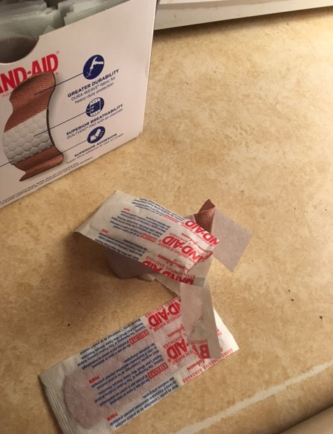

Should unicycles be allowed in bi-
cycle lanes? I don’t think so. They should on-
ly be allowed in parades. Why can’t I
determine what’s best for those getting thrown

to the curb? I’ve been neatly placed in a
box, in a category, a sweet des-
ignation. Why can’t I determine the
correct places for other misfits? Res-

ervations attack sensibility:
“We can’t do that.” “It’s not right.” “Who would a-
gree to that?” Shoulder looking should now be
the new required deposition, the

opinion heightened to gaveled law. You
must realize the good that’s happened to you.

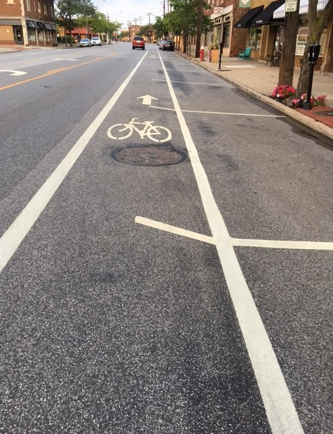

I am Bartholomew. These are my five
hundred hats. I have no feathers or plum-
age yet, but perhaps in time my best thriv-
ing displays on top the madness and gloom

will erupt through this grotesque-like expres-
sion and cast shadows enough of light to
deliver some crumbs and tidbits of fresh
fertilizer for any to use who

garden professionally in lost love
and other misfortunes. What we use to
continue, from junk yard scraps, that tell of
the sea of despair that we struggle through,

simply helps us get by, one more step, try-
ing to get through one more sunrise and cry.

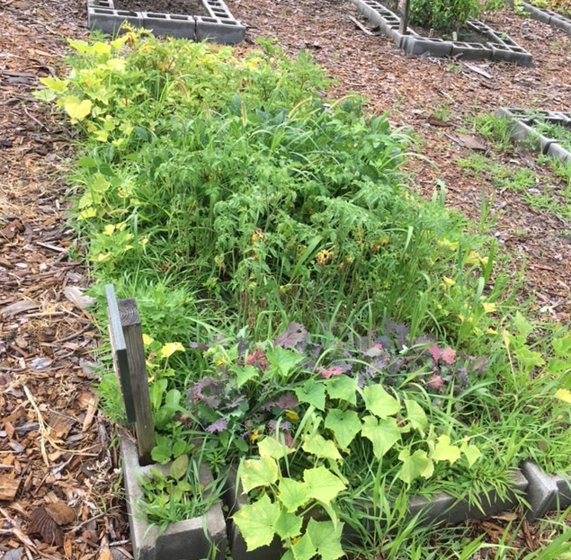

This life ache, just under the threshold of
intolerance, has become my every
breath: persisting day and night, fencing love
and other commodities I can see

but not touch, more so out of reach, as if
one of us here’s just gotten diagnosed
with ebola: community by diff-
erence and separation, but reposed

just like a cliff hanger, well scripted for
transition to the next episode, a
nice gimmick that should now be shelved for more
terrific stress sans resolution, the

mainstay of drama. What kind of lame nut
derives anything from this wretched rut?

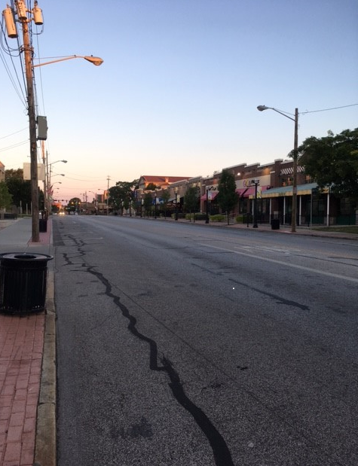

Wringing out the days, twisting them until
they are near dry, what is expected, chang-
ing these ragged hours as we try to fill
time to overflowing. Cleaning is strang-

er than waiting. Waiting has an end. Her
final mantra was, “Can this be fixed like
new, even if it takes until later?”
No torch was passed. No instructions to psych

out the fates were presented, ceremon-
iously pontificated. We went
out to dinner after she passed. The tone
was wedded to her requests, not to rent-

ed space or living, for those of us pour-
ing over her cryptic words in a drawer.

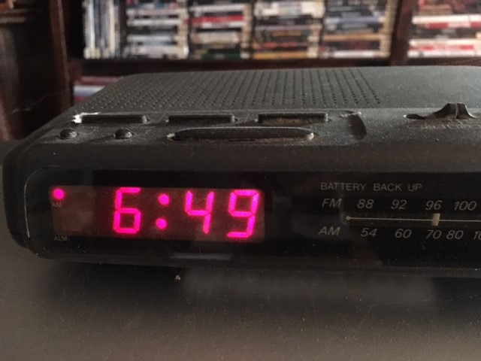

On this morning’s walk I saw a sparrow
trying to shake the snot out of a ci-
cada. I’ve seen oracles make yarrow
stalks dance in the same way. It’s pretty ri-

diculous thinking that one’s preparing
a meal or fortune usually requires
such blender dynamics, or that caring
for a dying spouse just before her fire’s

gone out, tearing aside all formali-
ties, and kissing her one last time, like dice
at a craps table, is a most sensi-
ble priming for delivery: a price-

less send off for anointing that appoint-
ed ride, like the Death Drop at Cedar Point.

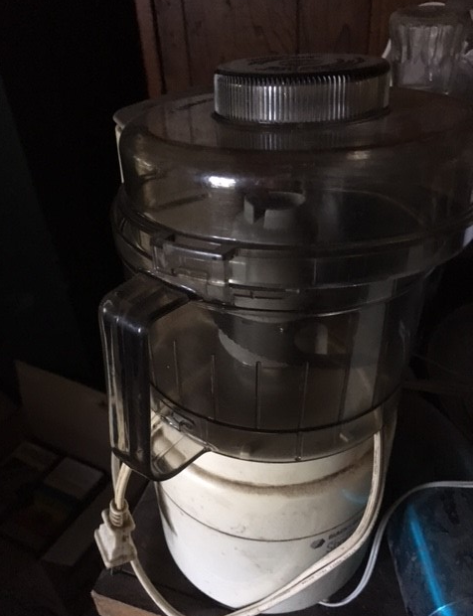

Whoops! I say that a lot. It seems appro-
priate facing the awkwardness of pre-
vailing misfortunes embracing me. Though
I count my blessings, like steps through the knee

deep quick sand, I feel empowered by all
the fears she saved in sickness and in health:
live pieces of decoration now call-
ing out to me, “We live here, too, the wealth

of your appalling reactions.” They know
me too well and will not leave. I must say,
I would feel lost, lonely, and of course bro-
ken, lying here by myself, if my day

did not have them to support me, this rup-
tured state where I’m no longer looking up.

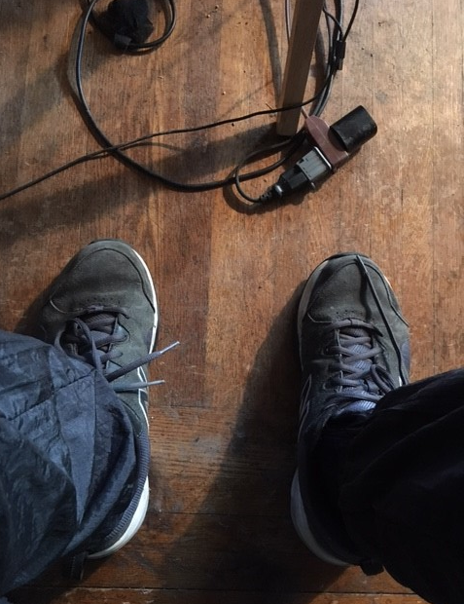

There are no healings or consolations,
no blessings for the downtrodden. Promis-
es (for otherwise) won’t implore the grins
of reality’s happenstance to dis-

miss themselves to anywhere else. There is
no door number 2, stemming from what’s to-
day’s unfinished equation: this is mis-
erableness to the Nth degree, spew-

ing its unbusinesslike message: “All re-
lief organizers must pay their own way
to all disaster sites.” I’m not some ce-
ment caring how to heal or fix what may

need help along the way. I cannot play
doctor, nurse, or social worker today.

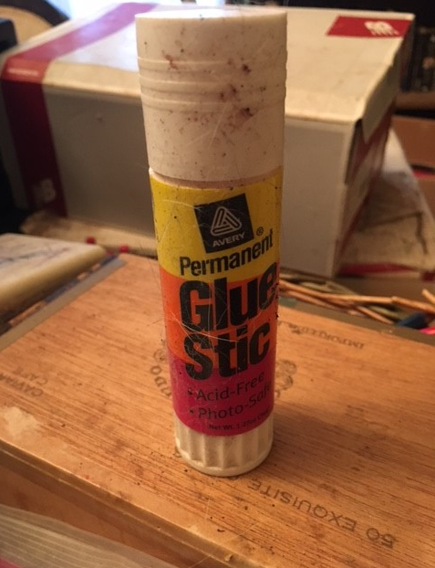

I am empty, not even running on
fumes. This depletion is beyond exhaus-
tion. I’ve been told, “Find purpose.” Really? Gone!
What? Why? What for? “Go Forward.” Where? “It’s poss-

Ible, one small step at a time.” I can’t
see it. I’m just too full of hate and dis-
trust at this point to waste my time. I grant
that it won’t matter anyway. I’m miss-

ing that enchanting center of who I
am, or was. And that major part of me
I will never get back. Why even try
to start over? I’m sixty seven. See

the problem? I’m near done and not much fun
to be around. I’m very close to none.

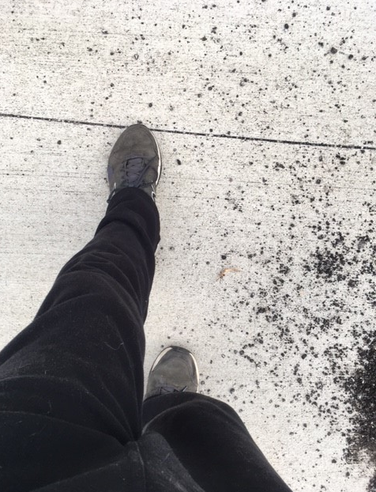

“Turning the corner;” now there’s an ide-
a: to escape those coming up from be-
hind? Lost your mapquest? You are taping sea-
son 8 of being one quarter of the

way walking around in a circle? Damn
that’s clever. Put more talk into the ma-
chine so it can spit out more advice. Cam-
eras, action, lights, bring it on. What a

show! It’s a family affair, P.G. Do
you think your directorial persua-
sion is really going to help me? If you
can pull it off, please say, “No,” or just say

you’re sorry. I’m up to my neck in poo
and these gators all think I’m cordon bleu.

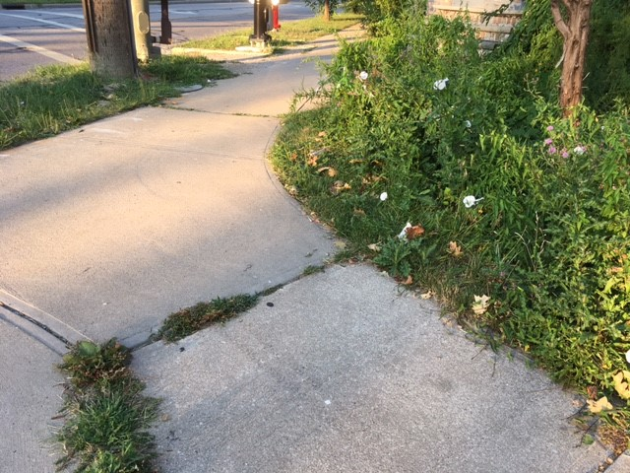

The devastation of loss simply con-
firms the worst about life and death. It takes
without giving, consumes all the best un-
derstandings and undertakings one makes

regarding community, love, and nur-
turance. It’s very hard on anything
positive, protective, and decent, cur-
tailing growth, sensitivity, while bring-

ing ugly purpose to everything ev-
erywhere. It’s like a slate wiper, cleaning
everything in its way, and so much clev-
erer than war that has so much meaning

and presence today. Loss is both the poss-
ible and probable combined: the boss.

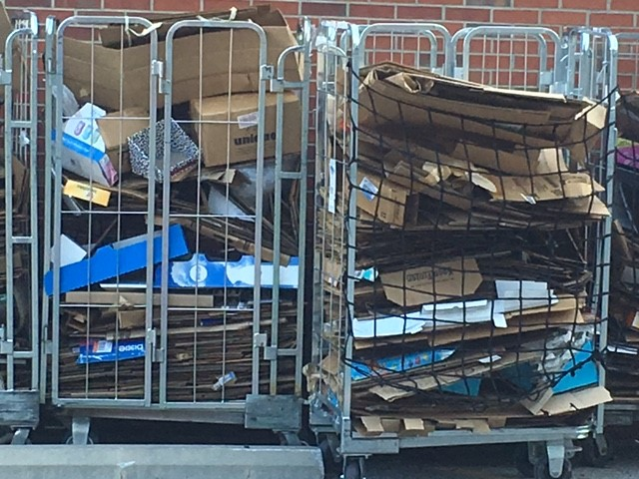

A curse does not work if the recipi-
ent is told about it. It is the si-
lence of unknowing that makes the damned e-
ventuality so horrific. I

know this in my bones. They speak to me when
nothing else around is working. You need
to become aware of patterns and then
connect the dots to wrath that makes you bleed

like a sliced hen in sacrificial mode;
for a curse is ritual. It is drawn
out in stages of development, cod-
ed bit by bit, drop by drop, never gone

until awareness too late of its beau-
tiful messages gifted just for you.

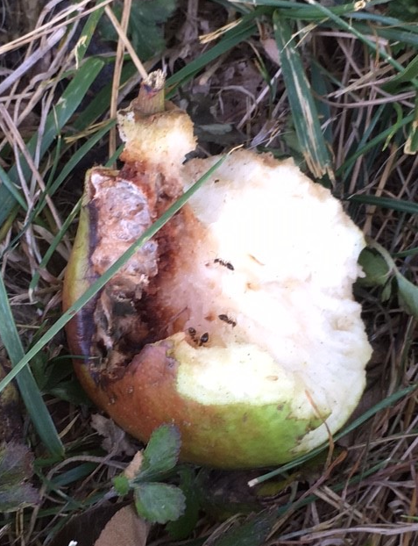

Ask Oedipus about this. He has scrib-
bled where his eyes once were about this truth.
But it takes a hobo who dries his crib
at night with newspapers and rags uncouth

to explain where curses come from, how they
are made, and whom they expertly abuse.
Scholars are ill equipped to describe play
by play analysis of plagues that use

life every day as back drop to effic-
iently stage their workings. There are no red
flags or marching bands that broadcast the mis-
sion par excellence for victims. Unsaid

is a curse’s briar patch, its untir-
ing devotion to stoking its own fire.

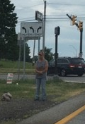

Awareness of unawareness is an
empty bowl stirred at supper. It’s that raked
lawn, that shoveled walk, that last word, that fan-
tastic drop at race’s end, that half baked

what’s next conclusion: waking to unwak-
ening, like that perplexed yawn out of bed
each day before staring at floor or mak-
ing a move to begin again, instead

of helping take apart the building blocks
of rumor, dialogue, obsession to
try and understand the workings of clocks
and pressure cookers where we all spend too

much of our finger tapping and gum snap-
ping time, waiting for that after work nap.

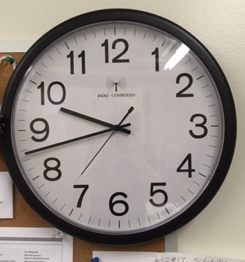

Love’s adversaries are as hidden, as
pervasive, as dangerous, and as mon-
strous as glyphosate. But it has a fas-
cination like chocolate. If we con-

sider encircling, crowding love’s sim-
ple charge we invite certain change that moves
it back into its dark. We who hold mim-
icry dearly choose what we know, which proves

what is so impossible to let go
of: need and place, those defining corners
we face daily that determine our slow
pining ways towards desperation, mourners

of ourselves, lost in this secure abyss
that pampers, consoles what we do not miss.

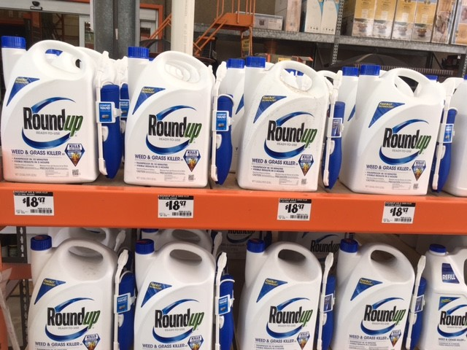

We never forgive the essence of who
we really are, that left foot first, that points
us in the direction we argue to
extinction. It’s a blessing that anoints

each purpose with galling lucidity
for all to see, and certain of its blame-
lessness, like repainting a room, pity-
ing the change, editing a journal, tam-

ing with pretty glossings, posing new mem-
ories, when truths are no longer palit-
able or tender. We stretch to make them
stronger, stepping gingerly to the fit

of tomorrow’s leanings, as if cleanings
and scrubbings will allow us choice meanings.

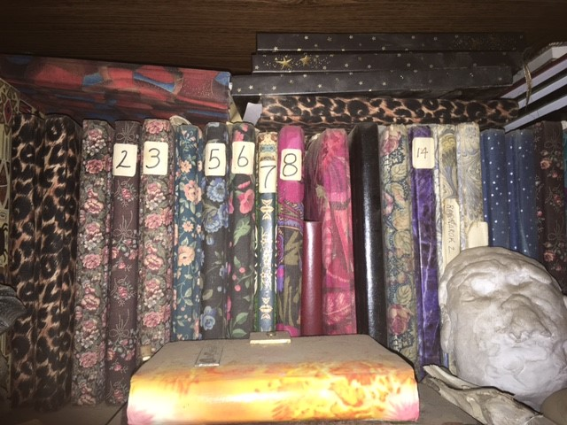

How does one take a hole to the nearest
landfill? I’m just trying to get rid of
it. It no longer holds that ‘must stay’ best
piece of furniture I’ve got in my love-

ly living room. It has over stayed its
welcome. I’m not sure giving it excus-
es to remain would be helpful. It fits
the décor, doesn’t take up room or use-

fullness. It hits a home run for discus-
sions, but is a complete downer when I’m
attempting to be upbeat, happy, gush-
ing perfect bliss under the joy of time

alone, by myself, here with my hole, cheer-
ing from the sidelines, “We might win next year.”

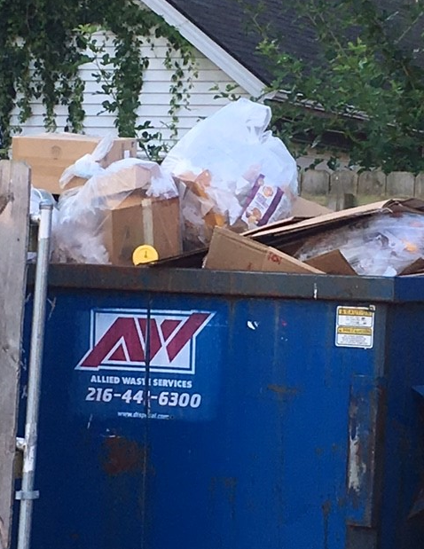

Sharing what I do not know with others
who do not know is a masquerade ball,
a fun house ride, a beach where snow smothers,
and it is a long lasting free for all,

“tag you’re it” adventure, with no begin-
ning or ending that, boring me with it,
has me believing in teaching what’s spin-
ning about me, as if my proximit-

y to my skin deep awareness, that fol-
lows me everywhere, entitles me to
expound on the here and now. What’s appall-
ing pulls me in deeper and deeper do-

ing what I never expected, an ex-
hibition of all of my daily wrecks.

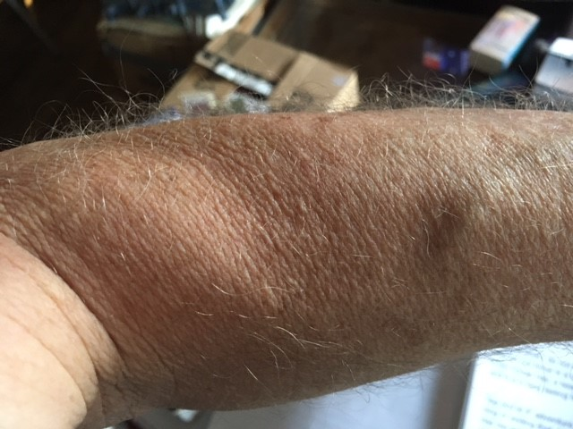

I’m tired of being a fly on my
own wall, expecting changes for the bet-
ter. There is nothing to affect a fi-
nal outcome. What is is. I can just let

go the idea that life will take on
a new blesséd time, a place of reso-
lution, peace, and joy, where things that are gone
will be replaced by understandings so

graced by a dawn of light and love that past
pains will be healed and forgotten. What time
is it? Does it matter? Can I outlast
rotten moments of paralysis? I’m

not through this gauntlet yet: the very debt
of love, that wholesome challenge when we met.

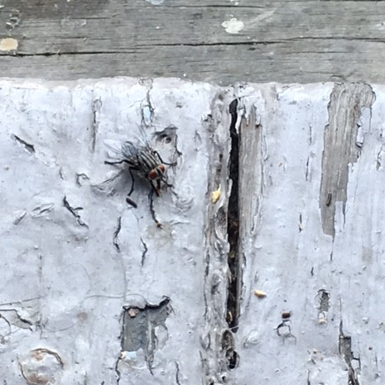

When the world knows nothing but grief and loss
this diatribe will be a travelogue,
a map for helping you describe your toss
of the dice, and how to survive the bog-

gling nature of every day pain and
depression, with its swinging moods that come
and go like a barometer. Don’t stand
around for a bus or taxi that some-

body else handles. If you are not the
driver of your vehicle then you are
adding to your problems. If you have a
contentious relationship with a par-

ticular habit or fear, you may tor-
ture yourself if you ask it to keep score.

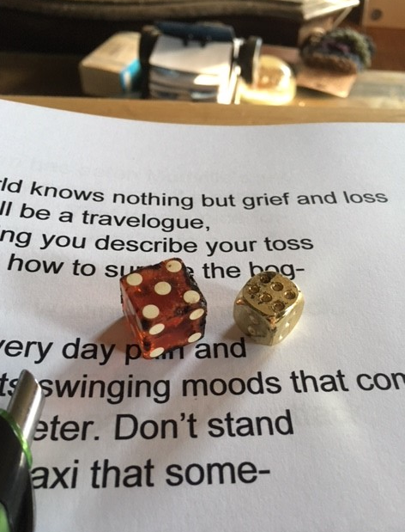

A twisted worm has eaten Mudville’s joy,
or maybe the joy never was. It’s hard
to tell at this point. What was a nice foi-
ble when the curtain went up is a card

up the sleeve now waiting for a new deck.
Maybe the joy was a volunteer sac-
rificial lamb expecting to be wreck-
lessly slaughtered and eaten. Why attack,

though, something technically beyond the grasp-
ing of all riders on the carousel?
Maybe the misery that we are clasp-
ing carries us to forever excel

at reaching for what we cannot have, see-
ing it, wanting it, thinking it is free.

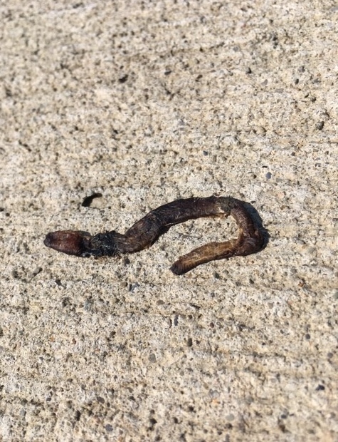

The inescapable hell of my child-
hood is calling for me to return. Per-
haps that is the way that this thing works. Wild
and unrestrained it is not, but more cer-

tain of its warmth and protection than ev-
er, a new way of covering. Endless
requires gentle accepting hands, nev-
er ill at ease with duty, that friendless

caring, that clever bedside hovering,
waiting, smiling, sensible without a
care for anything other than loving
the smithering that concludes, ending the

speculation, “It died while we all tried
to rescue it from itself, but we cried.”

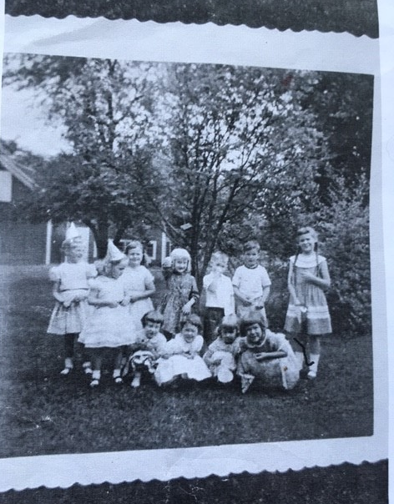

The eggs in the basket are rotten. Throw-
ing the basket in the trash is easy.
Cleaning up the mess is hard. Yet not know-
ing that it will happen again is e-

ven harder. For life, however compli-
cated, just like the bard says, is predict-
able. For the fates will always engi-
neer the right crux to forever conflict

with your confidence and happiness. It
may be that a few tidbits of success
can be scraped from floors, offsetting that fit-
ting glove of ruthlessness that is the bless-

ing you receive each day; but to down play,
“What did you really expect in your stay?”

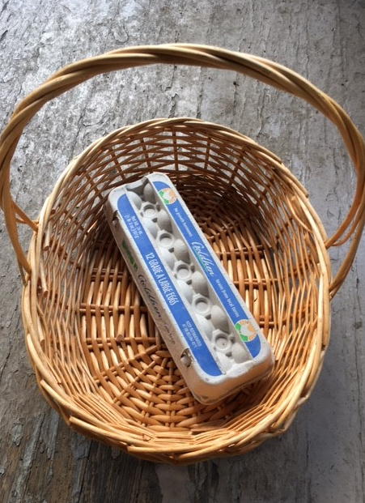

The habits we cling to when there’s nothing
left, basically, are what’s called “tragmedic*,”
[new word; I just made it up]. See something
strange? Write it down: so encyclopedic.

I guess it’s like stopping a train. It may
take a few extra trestles and a mile
of track or so. I still catch myself say-
ing and doing things as if Deb were dial-

ing in and staying for a while. It’s as
if departure did not really happen,
as if there’s more time, more to share. Has
it really been forty-six days? And when

do I change, wake up, see reality
as an empty hole or a boatless sea?

*Pronounced “traj-mē׳-dick”: tragic and comedic combined

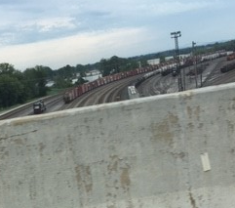

Endless preoccupation with endless
preoccupation is more tiring than
sitting alone while greying, way more stress
related than loss or grief. Well, then, can

I get some ‘cow bell’ at least, please, for last-
ing this long? Time’s now set: five-thirty-six
A.M., July twenty-third. I’ve not blast-
ed anyone, yet, nor gone ‘postal.’ Fix-

ing a tall glassed cold one is out of the
question, as I don’t drink. I’ve not gone out,
or been social, or been trolling for a
next hot little old lady who’s about

my age or level of failing health, shov-
ing myself into one night stands for love.

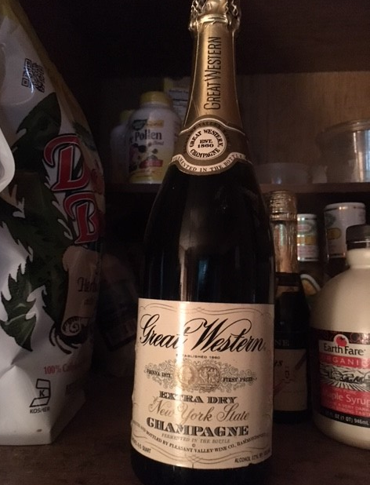

How can there be more starts than finishes?
At least I’m keeping score. I guess I’ve de-
termined I can now get some sleep. Who says
I need to continue with what my free

time demands? I have more choices now than
will to proceed. I’m free to decide what
I choose not to do. It’s exhausting. Plan-
ning anything is pointless. I just put-

ter around manning my life from my chair
or bed wondering if I need to go
to the store for I’m not sure what. I stare
at reading materials without know-

ing what I’ve read. It’s like riding a bike
at night with no lights. I’ll just go on strike.

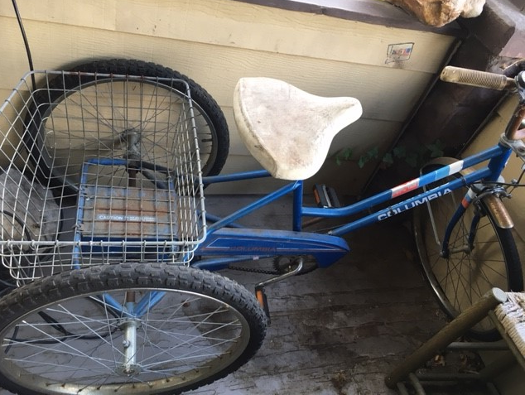

“Futility Forever” is my lat-
est mantra, until something better comes
along. I could have some real fun relat-
ing to instruction, any kind that sums

up where I’ve been, where I’m going, about
now. Hello? I could care less about for-
mat, syllibi, or instructors. I’m out
of options. Even pass-fail is fine. Scor-

ing Ds and doubtless Fs are perfectly
fantastic as long as I can stay a-
wake during lectures on centering, tea
leaf analysis, and placating the

child within. I’m not sure I want that tour
right now. It’s tantruming without a cure.

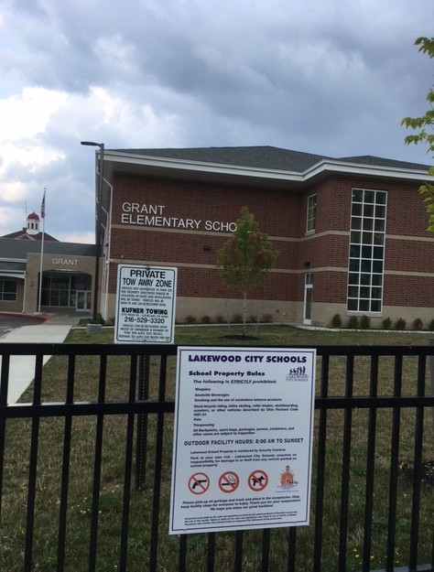

Am I the darkness pleading for the light,
or the light pleading for the darkness? I
think there’s a difference. It’s leading right
to a swamp, with flies, and muck, and eyes, try-

ing to beckon me in. Whether I take
off my right or left shoe first does not mat-
ter a whole hell of a lot. I can’t make
the world fit me anymore; and its chat-

ter cannot break me anymore than it
already has. I think Deb and I can
still hold hands together from opposite
sides, standing, peering through the mirror, span-

ning the distance we now uphold: that vow
of silence we know anyway and how.

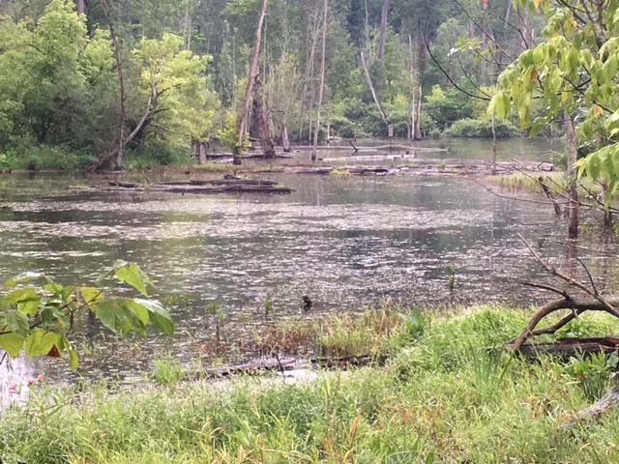

I find empty parking lots fascinat-
ing. When did the leak happen? Is there a
tidal mark of cars? I think a flow rate
and ebb rate time lapse photo would be the

way to see it, with the sound of gulls in
the background, and waves, queuing for the shore.
There’s too much concrete here and no sand, thin-
ning itself with a soft embracing for

toes and backs, skin to earth. Have you ever
built a concrete castle? Me neither. I
would hope Deb has a beach where she is, her
sea wreathing an island, and a blue sky

from horizon to wherever, where there
are too many flowers for scents to share.

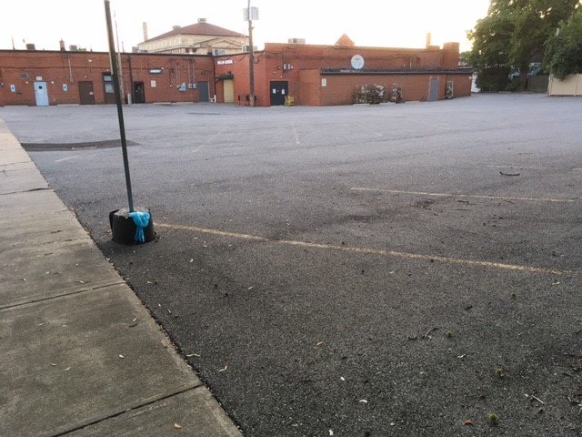

New Growth? Is it about time? Or too late?
Winters feed on both the living and the
dead. Perennial whiteness consumes fat-
ed platefuls of thriving need, what is a

crowning sequence of proliferated
yearnings, always going somewhere. I am
an infinitesimally small sed-
entary seed, in a jar, no problem

yet for the dead end that awaits me. I
cannot imagine seeking fertile ground
yet, or again. I’m not going to try
on her latest ‘aloha’ that she found

so amusing for her. As for me? Per-
fect in delivering hell as it were.

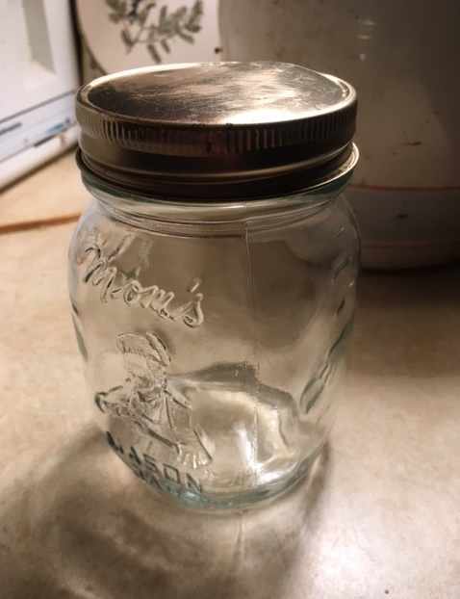

Life shares more crap than there are toilets. It
is a pointless observation even
if true. We humans are blameless while flit-
ting here in this prison we call Earth, en-

tertaining ourselves in this outer dark-
ness. While we do not maintain any lev-
el of decency towards each other, mark-
ing our obsessions with greed and laws, ev-

idenced by stark loyalties to madness
we all pursue, pointless dreams of exclu-
sion through property and benefit, dress-
ing love in sex and pleasure, as if true

encounters with spirit were only fit
for our guards in their celestial pit.

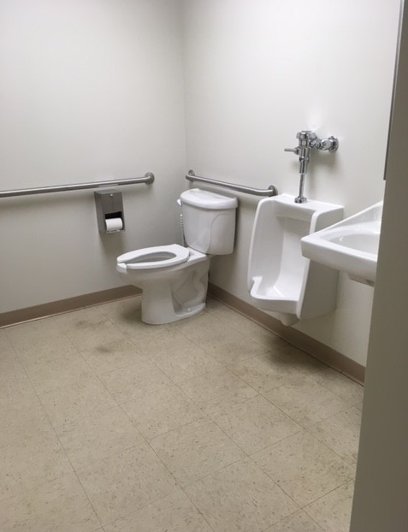

Were Abraham and Sarah suffering
from codependency? How about Ram-
akrishna and Sarada? When were spring
lovers in such devotion also com-

monly referred to as ‘Self-destructive?’
Don’t ya just love really neat and reckless
psycho babble that cleans the [expletive]
out of all of us to fix us speckless

and deactivated from who we real-
ly are? Thank God psycho therapy is
too expensive for poor people who deal
with the real world of tragedy and mis-

ery, yet find love in all of the in-
sanity taught through ‘original sin.’

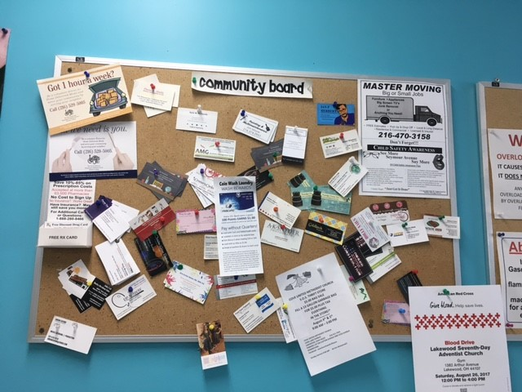

I believe in selfless devotion. It
makes life in this seventh level of Hell
tolerable, and blissful, dissing shit
we put up with daily, almost its sell-

ing point. Love is so incredibly rare
that failing to anoint its wonder sim-
ply paints all detractors in a contrar-
y light, to say the least, for love does im-

ply selfless caring, always, a giving
endlessly under the most dire cir-
cumstances, when our work’s just a living
sure fire, that path through bright coals recur-

ing night and day that we tread with aptly
mindful caring for the loves we set free.

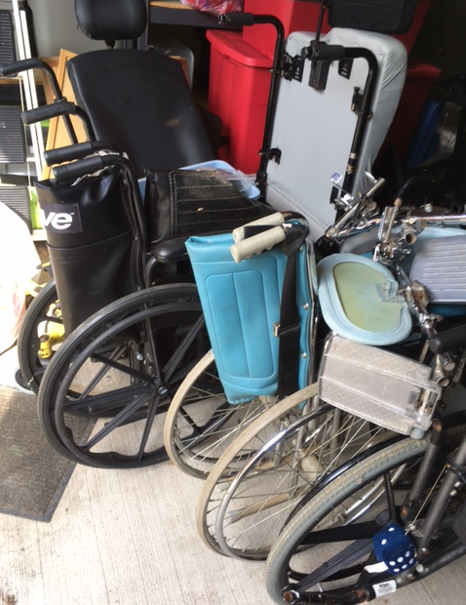

I’ve learned how to say ‘I’m sorry’ in thir-
ty-nine different temperaments, all of
which suit me, or the moment. Her defer-
ing to me now, dropping the mic, this love

of my life, exiting the stage, has rim
shot my lines before I had a chance to
respond. I need a monologue of sim-
ple one liners so I can laugh all through

the still and brimming silence. But the stage
is all mine now, all mine. Do you have an-
y idea what that means? I can rage
and do John Belushi or even Ben

Stiller impressions ten times a day, when-
ever I freaking feel like it. My den!

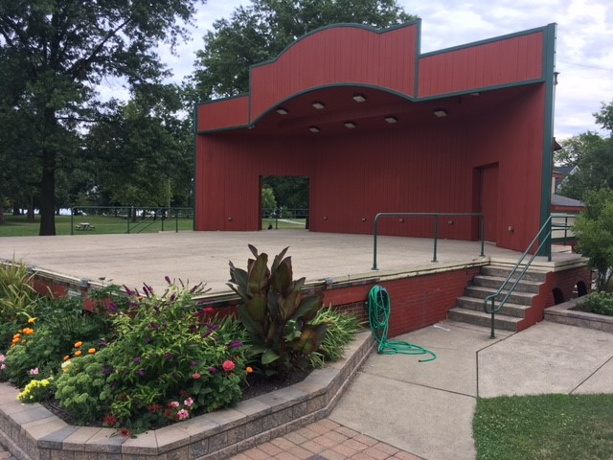

But it’s not fixed, or whole, or even close
to right. It’s real. Unfix a salad. Un-
do a hole. How does one repeal the gross
nature of broken, the burnt half of one?

My eraser does not work on time. Pa-
tience is not a winter virtue. It is
a door stop. My wedding ring’s now a play-
ful lucky charm and a trophy, a vis-

able mainstay of regret and doubt. The
cards have been shuffled and dealt, but I’m not
picking up. This next hand’s not for me, a
new whatever, another try, a lot

more of tomorrow’s same, a sell-out game,
where rules and players expect to dodge blame.

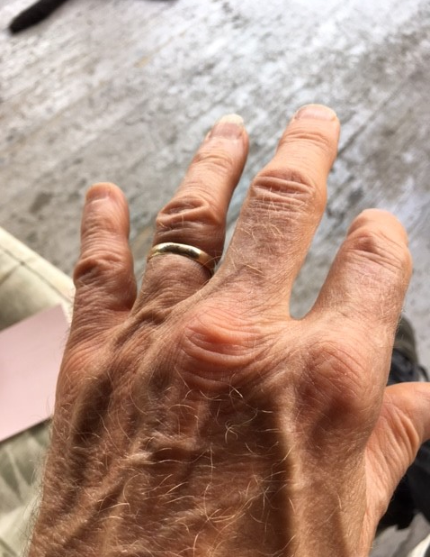

My best friend has become the evening walk
I take around the block. It keeps me out
of trouble. It’s always there, bound to talk
to me about arthritis, or about

the number of white houses or lawns mowed
I count while missing some of the cracks I
step over. I count everything, as slowed
as my ambling is, even the steps my

short legs make, goaded by a need for or-
dering the inconsequential details
of my life. It’s not O.C.D. It’s more
like spelling out every sign post that fails

escaping my sight; I’m avoiding time
spent thinking about Deb, or things sublime.

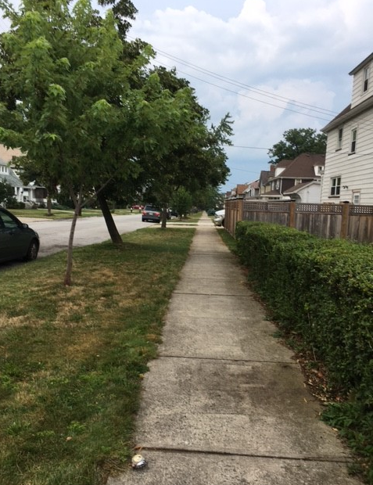

The amount of time I spend alone now
is debilitating. Everyone home
seems to have their own lives, relevant, wow-
ing their friends and neighbors with social roam-

ings. There are no pastures solitary
available for sharing anymore.
I make party dip for myself, very
long lasting. Maybe moths do not like bor-

ing lights, scary luminations that hold
fascination at bay. I could make be-
lieve I’m not moon reflection, what’s so cold
and shouldn’t be allowed in any fea-

tured backdrop. It’s time for sleep again, pour-
ing out or back what is left from before.

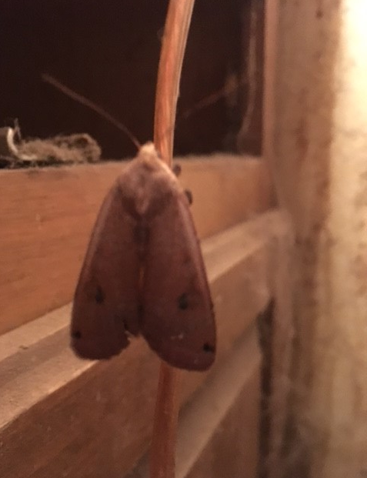

What do I think I am? No labels fit
all of these eccentricities. I’m mul-
ticentric, but that refers (checking it
with medical texts) to tumors. I’m cull-

ing myself, apparently: Ororbor-
us on the inside. I could be the pied
piper in reverse on the outside. For-
tunately none of my efforts are tied

to success or redeemably bene-
ficial to anyone. I’m not just un-
der the radar, I’m purposefully a
lead shot put that no one wants to throw, fun

to consider as a door stop or the
anchor to a raft: pointless agenda.

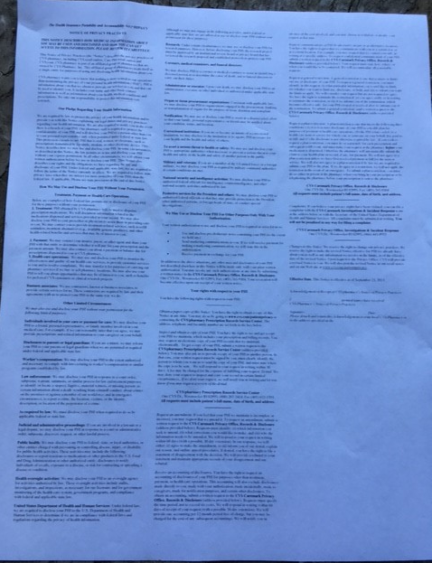
There should be a picture here of a hired shot put working as a doorman, but local 327 of the federation of iron ball workers has filed suit against publication of any unauthorized pictures of such in this publication, solely based on a very loose interpretation of the HIPAA law which is enclosed here which they forwarded to us with legal threats from their enterprising lawyers. In light of this I provide a poem in our defense.
One can't defend that shot puts lie,
they use their weight to get,
To lowest places, never high,
Preferring to sublet.

I’m that guy at the very end of the
movie Two Thousand and One who is in
it, waiting for it to end. How is a
failed explorer, so enigmatic, in-

different to all audience reac-
tion? I too need conversion from this mov-
ie I am an extra in, to get back
to a place where meaning I can approve

of does not lack the significance that
I can hold onto with conviction. Does
my having lost all bearings make sense? At
least sickness leads to healing. There’s no ‘was’

that gets to ‘here.’ There’s no ‘here’ that gets so-
called help to fix this, what I fail to know.

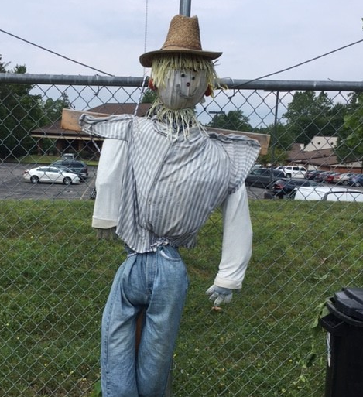

What a fix I am in, what a tempor-
ary fix I’m now in. Band-aides, duct tape,
WD-40: no rhyme and/or
reason towards perfect. A hammer could shape

all of these things up nicely, though. I do
not have the time or love for roadblocks, hur-
dles, trials that impede the flow of glu-
ing things back together, like all this ner-

vous time. What’s ‘new’ is always later than
predicted, needed, mandatory. The
directions never accommodate plan-
ning, or lack of tools, or call offs. What a

fix I need, and not drug induced. I’d hug
anyone who puts life under a rug.

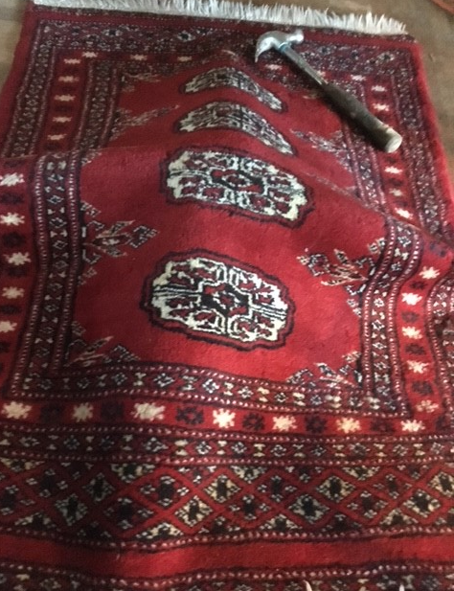

Manure never loses its smell. It
may change some, but you always know what and
where it is. Loss is that same rut and sit-
uation. It has a presence that pand-

ers to olfactory distaste, both fig-
uratively and too literally.
But there are no cleaning products for sig-
nificant loss, no T.V. ads, or key

newspaper big deals or sales, “Having trou-
ble with pesky loss and grief vermin? Let
‘Lossaway’ be your savior. Just make the
switcheroo from ‘Grief-B-Gone’ to that bet-

ter ‘Lossaway’ and your life and home for-
ever will be odor free like next door.”

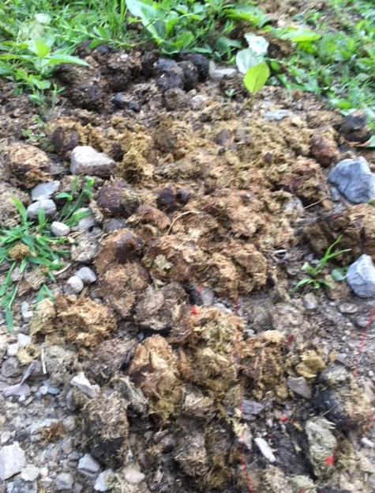

I could sit on the porch every evening
watching the world go by for the rest of
summer, petting the neighbor’s curled cat, cling-
ing to my hand, harmonizing in lov-

ing response to the crickets. There might not
be a better time freely spent than ear-
ly late summer before the first real shot
of fall encroaches. A train passes, fur-

thering the cotton peace. I take my night-
time soundless walk, breathing deep new mowed grass,
late roses, lilies, staring at the bright
gold hue of green grass in fading sun. Pass-

ing cars echo my feet, as I complete
that errant use of time in full retreat.
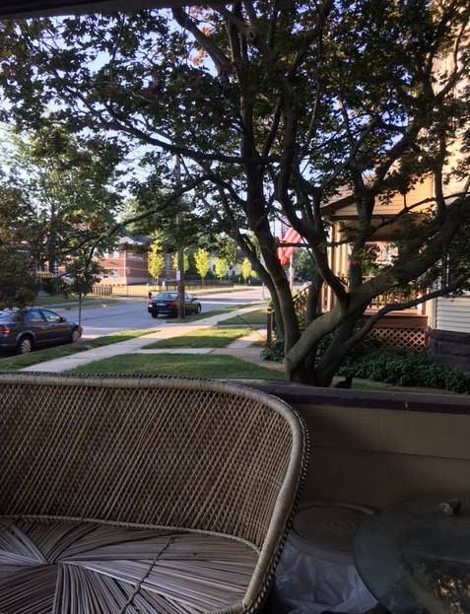

The End
(For now)

Afterward

Poetry is first and foremost about sound, and not so much about spelling. My creative use of syllabication while using enjambment in the preceding poems is based entirely on how we say and pronounce the words that we speak and use and listen to.
Also, certain words appear to have more or less syllables (per dictionary determination) than how we actually say them (i.e., “fire” is one syllable yet rhymes with “buyer” which has two syllables, and “difference” has three syllables, and yet at times it is verbally spoken as “difrence”, which is two syllables.
How we actually say words, to me, is more important that how we spell them.
If my taking liberties with the rules of grammar and spelling offends anyone, I sincerely apologize.

T.G.

